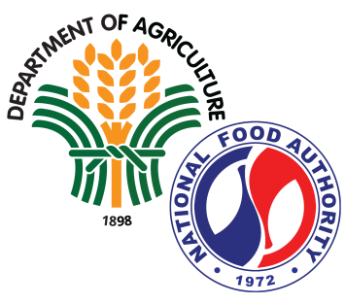

**NATIONAL FOOD AUTHORITY**

**Public Affairs Department**

**_____________________________________________________________________________________________________**

Visayas Avenue, Barangay VASRA, Diliman, Quezon City 1128 [www.nfa.gov.ph](http://www.nfa.gov.ph)

